Ak Bars
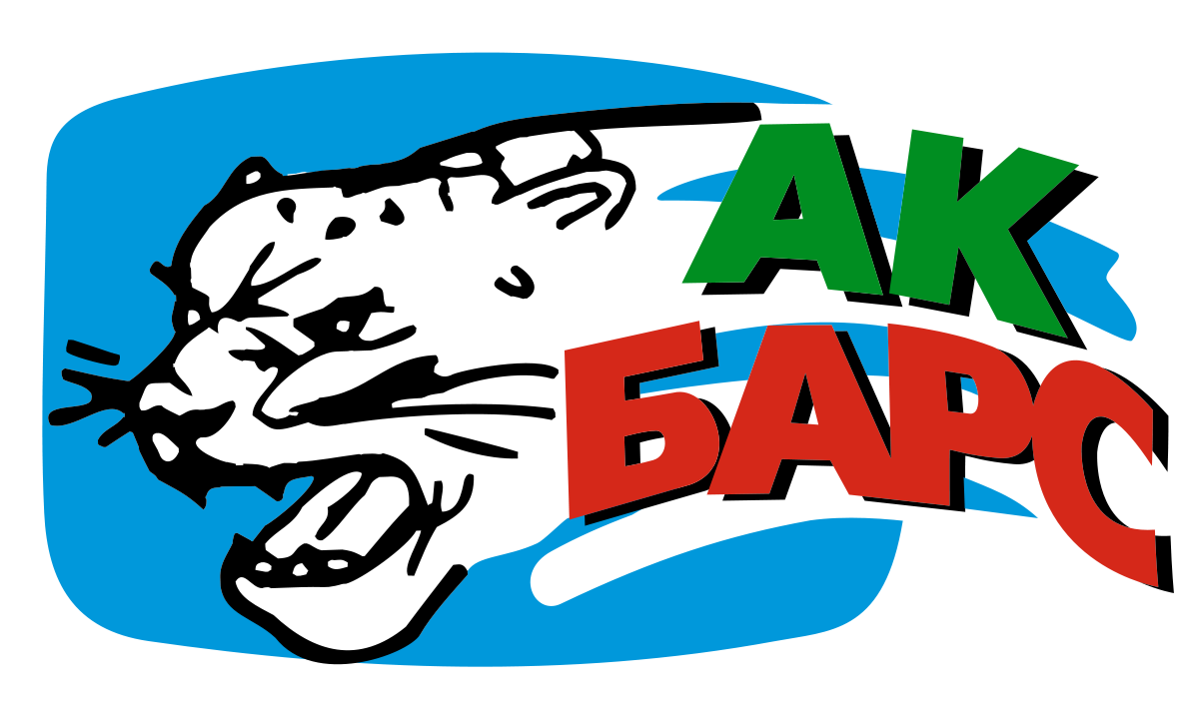

1st Period
- _________________________________
- _________________________________
- _________________________________
- _________________________________
- _________________________________
2nd Period
- _________________________________
- _________________________________
- _________________________________
_________________________________
_________________________________
- _________________________________
- Blue:___________Pink:___________
3rd Period
- ______________________________
- ______________________________
- ______________________________
- ______________________________
- ______________________________

Avangard
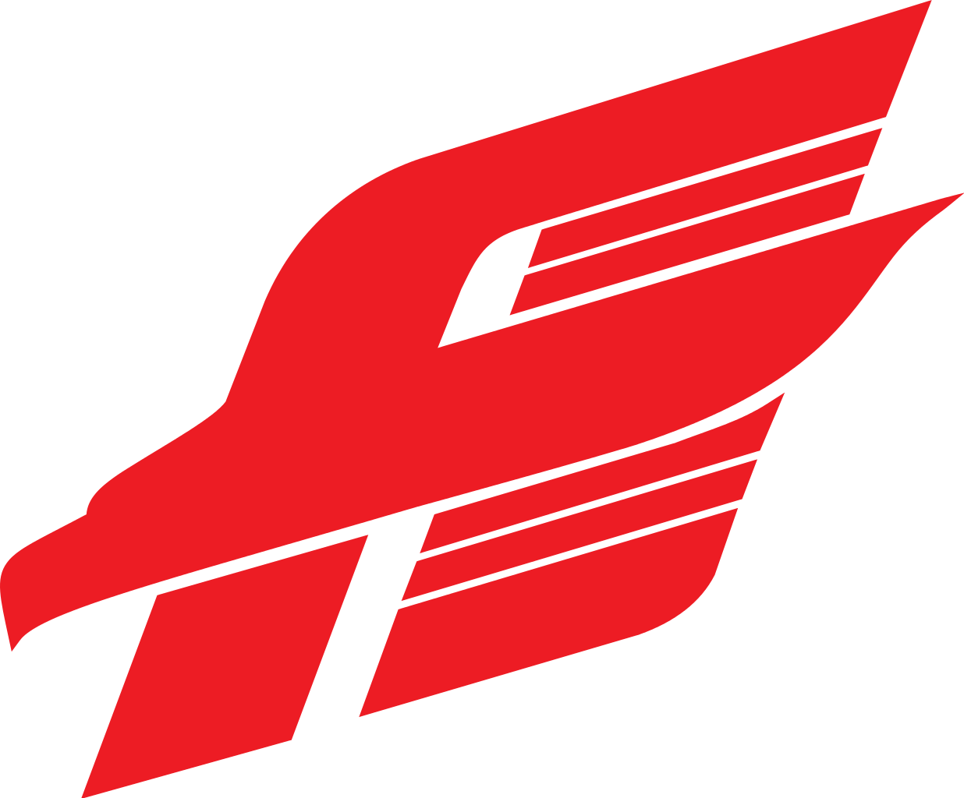

1st Period
- _________________________________
- _________________________________
- _________________________________
- _________________________________
- _________________________________
2nd Period
- _________________________________
- _________________________________
- _________________________________
_________________________________
_________________________________
- _________________________________
- Blue:___________Pink:___________
3rd Period
- ______________________________
- ______________________________
- ______________________________
- ______________________________
- ______________________________

Barys

1st Period
- _________________________________
- _________________________________
- _________________________________
- _________________________________
- _________________________________
2nd Period
- _________________________________
- _________________________________
- _________________________________
_________________________________
_________________________________
- _________________________________
- Blue:___________Pink:___________
3rd Period
- ______________________________
- ______________________________
- ______________________________
- ______________________________
- ______________________________

Spartak

1st Period
- _________________________________
- _________________________________
- _________________________________
- _________________________________
- _________________________________
2nd Period
- _________________________________
- _________________________________
- _________________________________
_________________________________
_________________________________
- _________________________________
- Blue:___________Pink:___________
3rd Period
- ______________________________
- ______________________________
- ______________________________
- ______________________________
- ______________________________

